**EXPERIMENT - 1**

**AIM: Realize all gates by verifying their truth tables.**

**HARDWARE REQUIRED: Power supply/ Voltage supply, Bread Board, Resistors, LEDs, Connecting Wires, Integrated Chips ICs (7404, 7408, 7432, 7486, 7400, 7402, 74266)**

**SOFTWARE REQUIRED:**

**Software stimulator (MULTISIM) –** [**www.multisim.com**](http://www.multisim.com) **(free software) Stimulating schematic models of desired circuits**

**Components used – Source (Clock Voltage), Passive elements (resistor), Digital components (AND, OR, NAND, NOR, XOR, XNOR, Inverter), Probe for Analysis and annotation (Digital), Schematic connectors (Ground)**

**CIRCUIT:**

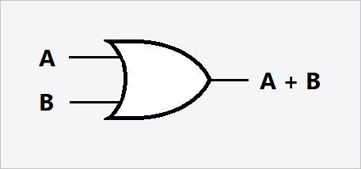AND GATE OR GATE

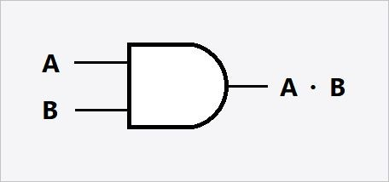

NAND GATE NOR GATE

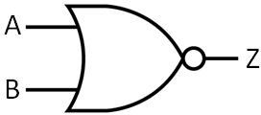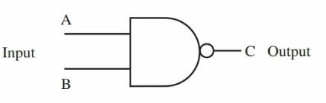

NOT GATE

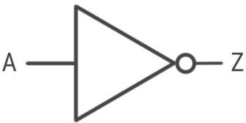

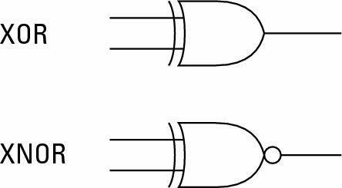

**PIN – DIAGRAM:**

# AND GATE

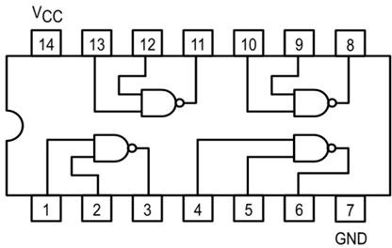**NAND GATE**

**OR GATE**

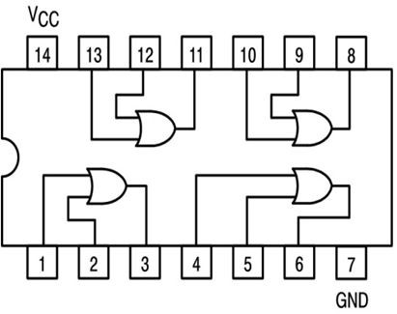

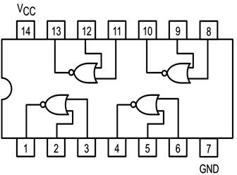**NOR GATE**

**XOR GATE**

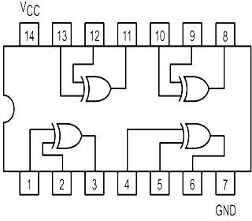

**XNOR GATE**

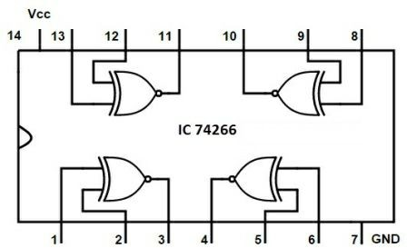

**NOT GATE**

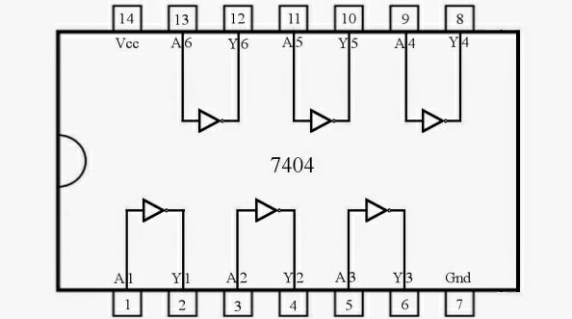

**TRUTH TABLE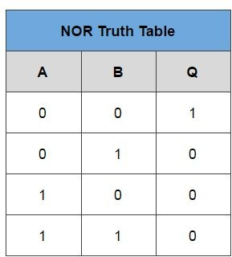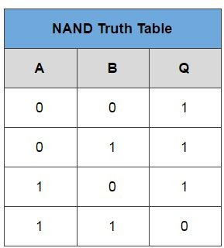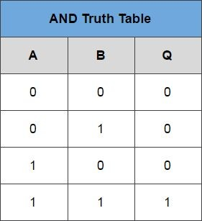S**

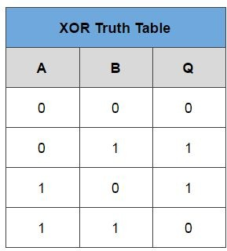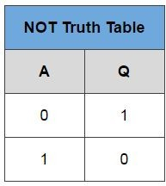

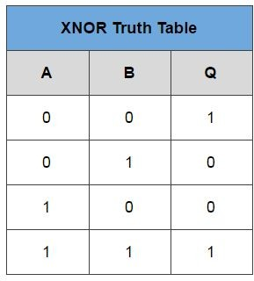 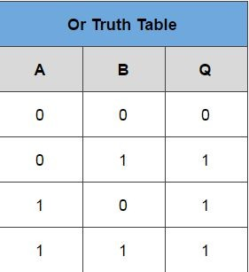

**THEORY:** Logic gates are electronic circuits which perform logical operations on one or more inputs to produce a signal output. There are 7 logic gates. These include the AND, NAND, OR, NOR, XOR, XNOR and NOT.

# PROCEDURE (MULTISIM):

* Make the circuits shown as shown in the figures.
* Select the required components (gates, resistor, voltage sources (Clock Voltage) and ground symbols from the tool bar on the left.
* Ground both the voltage sources (clock Voltages) and then connect them to the input terminal of the gate.
* Connect the output terminal to 1 k ohm resistor and ground it.

**Precautions:**

* Power supply should not exceed 5V.
* All the connections should be tight.
* Components should be tested before the practical.

**NOT GATE**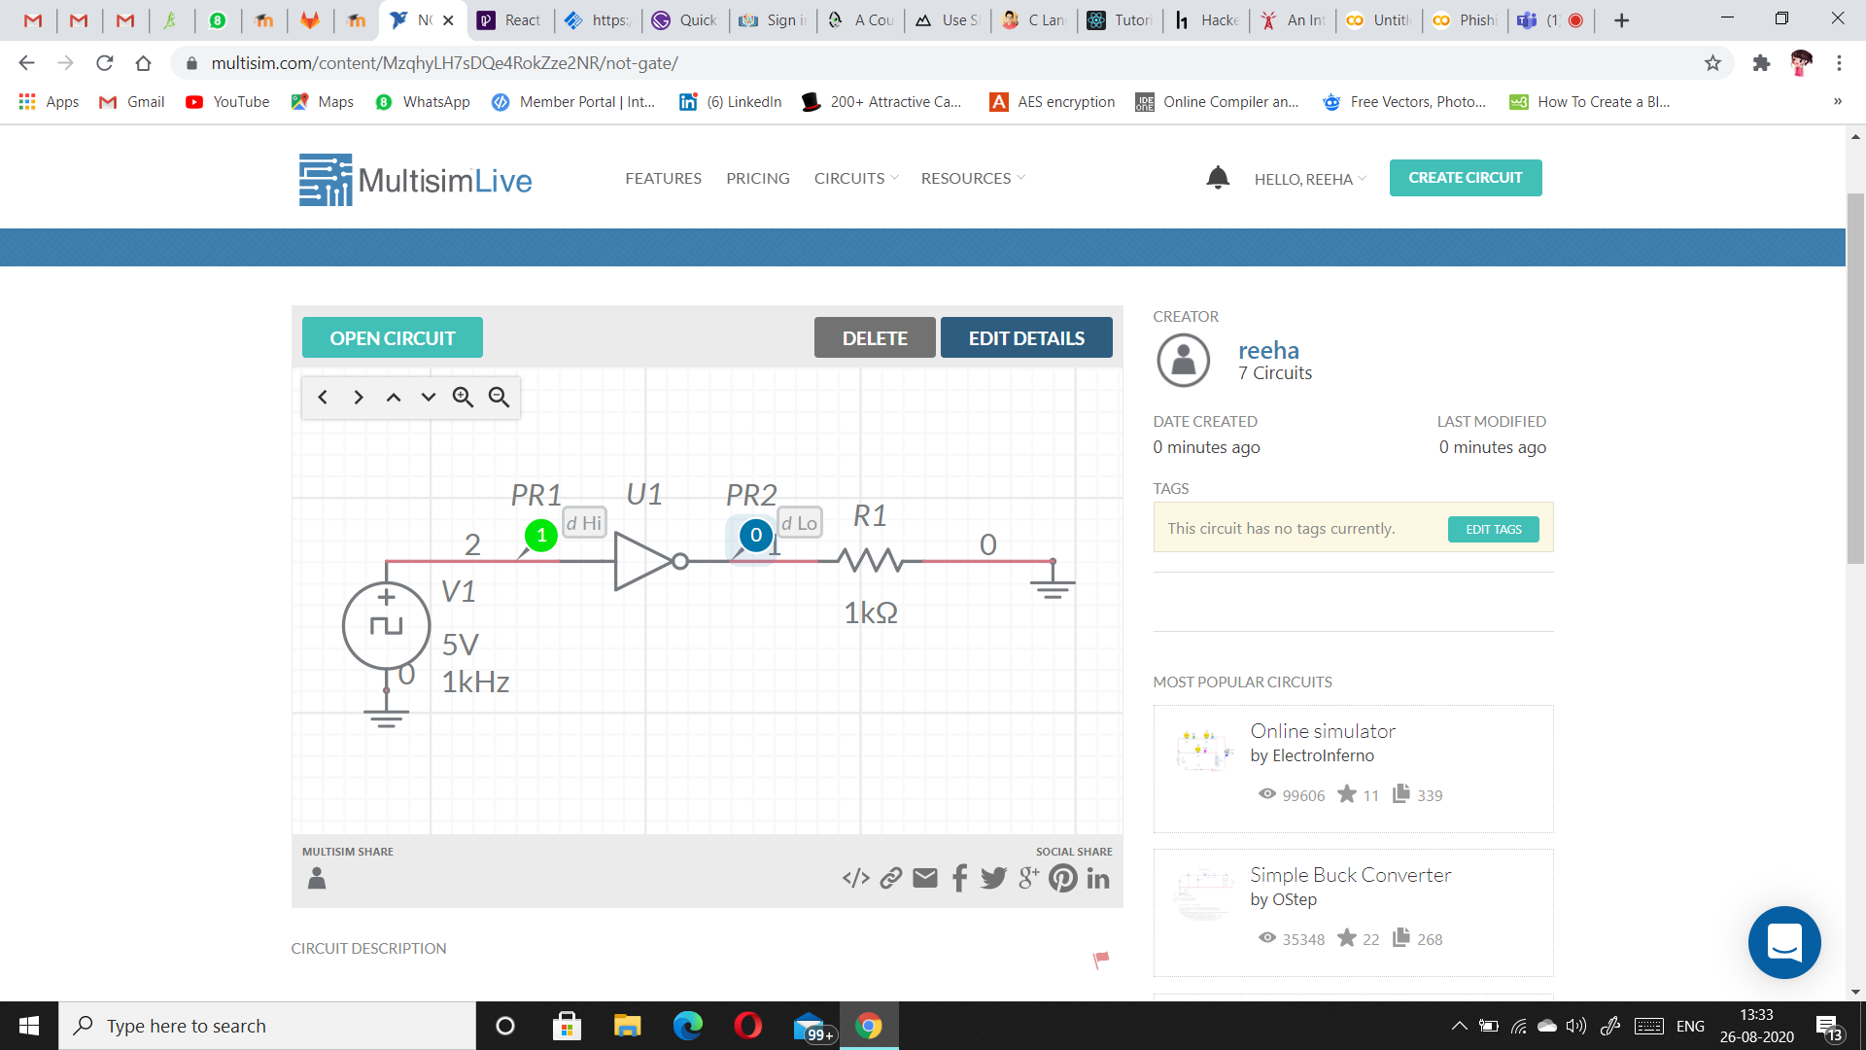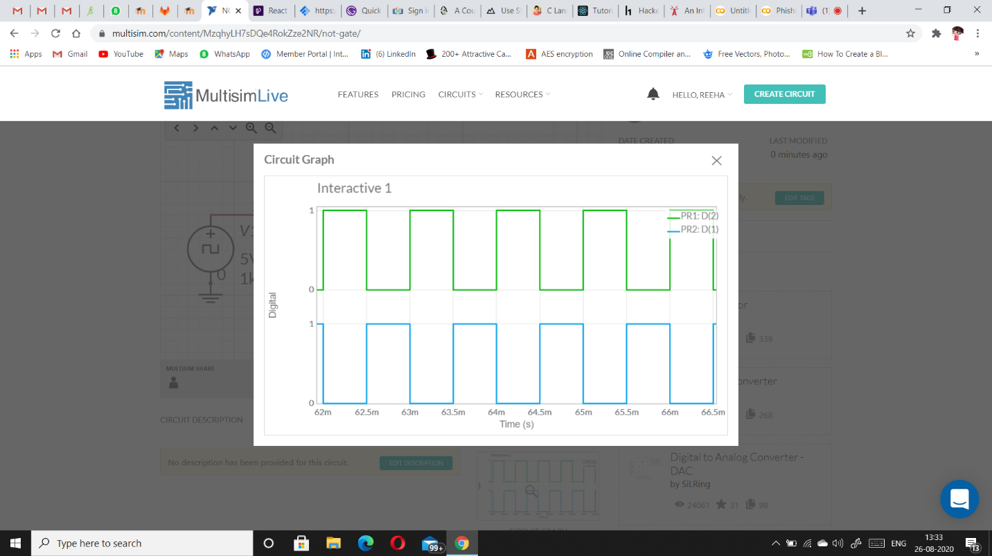

**XNOR GATE**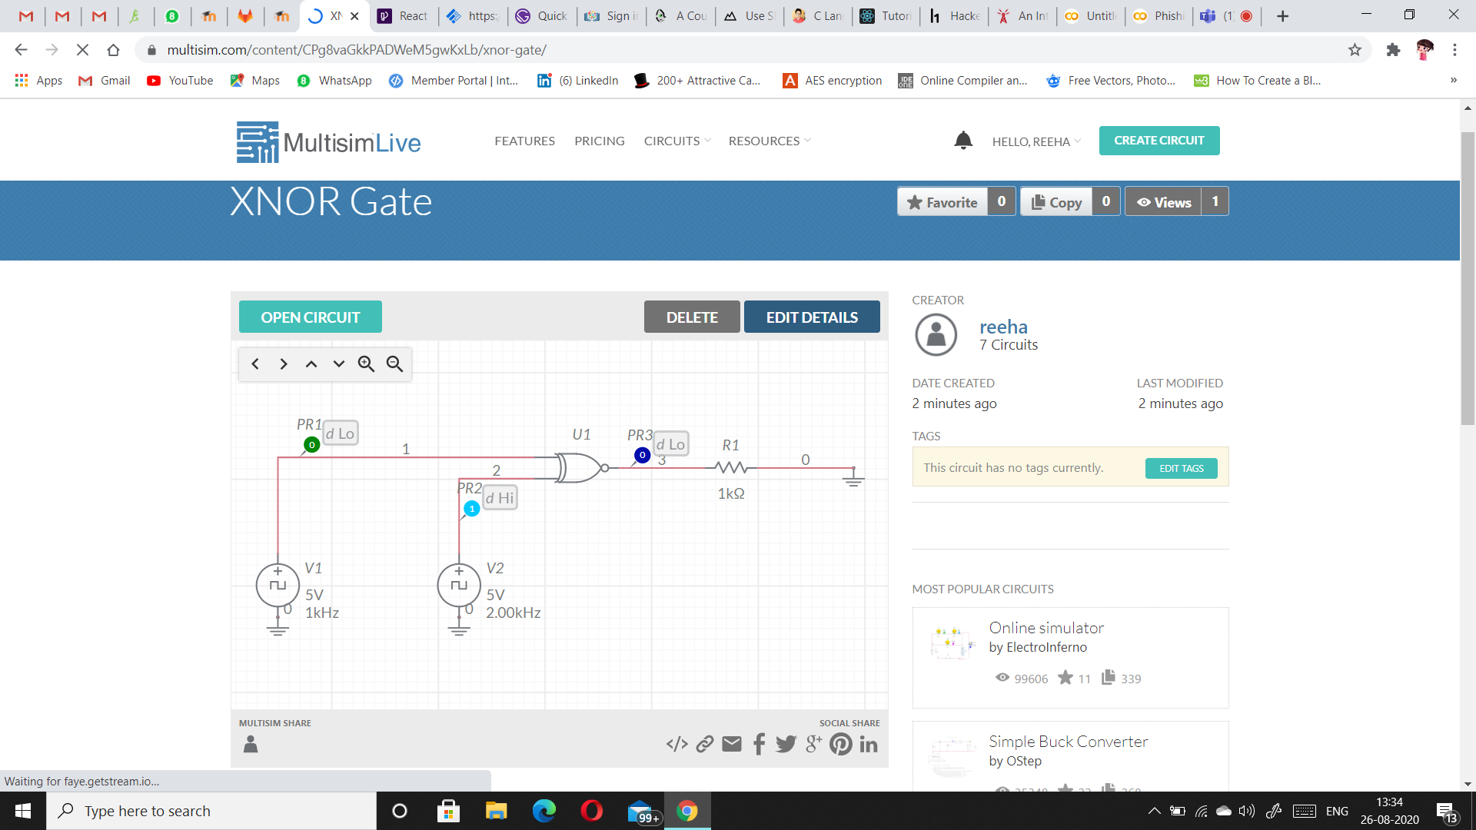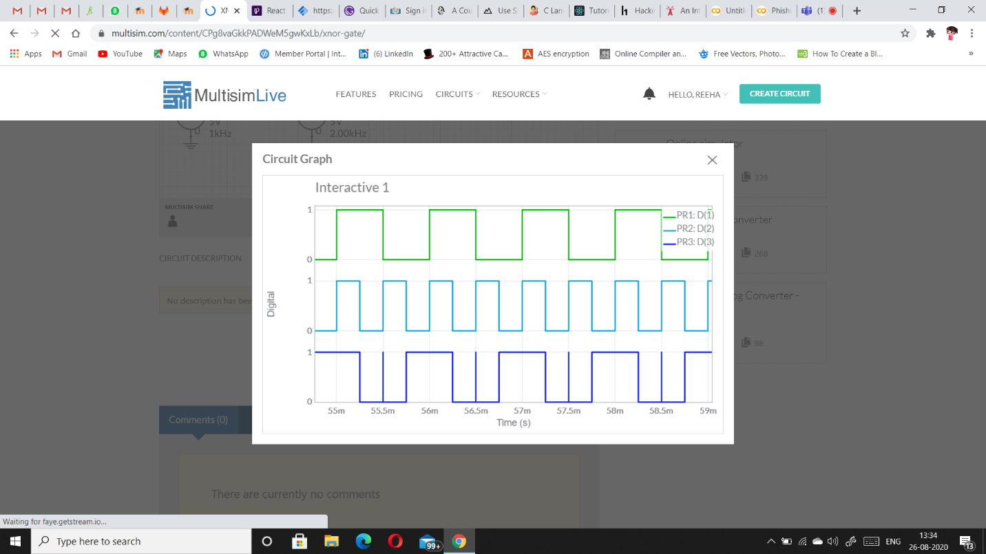

**XOR GATE**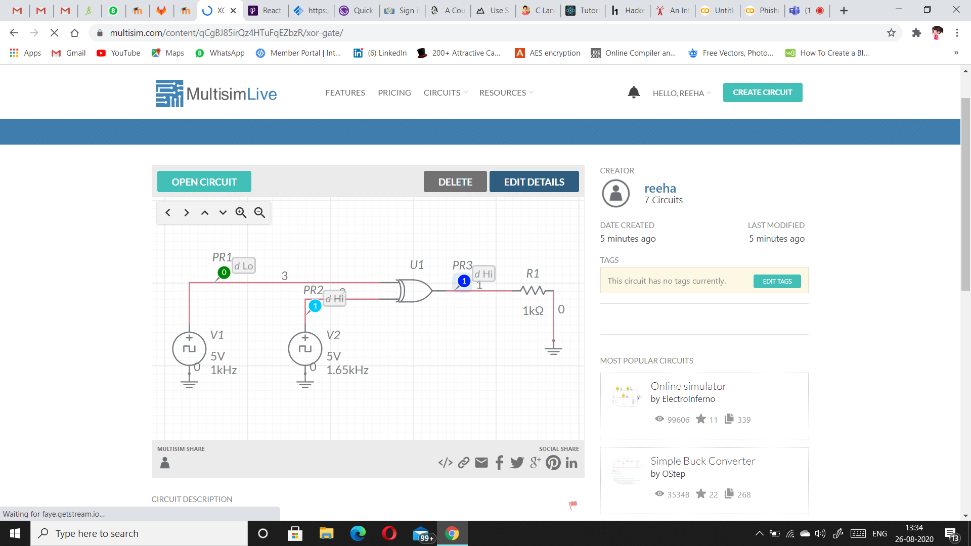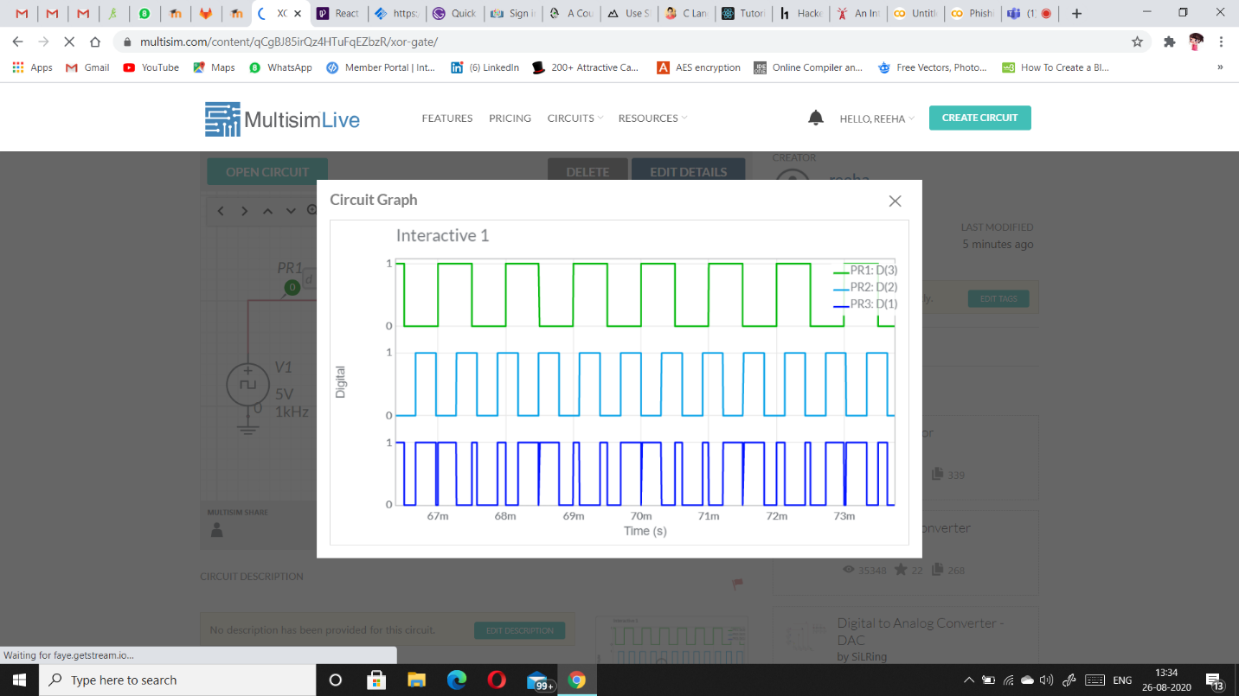

**NOR GATE**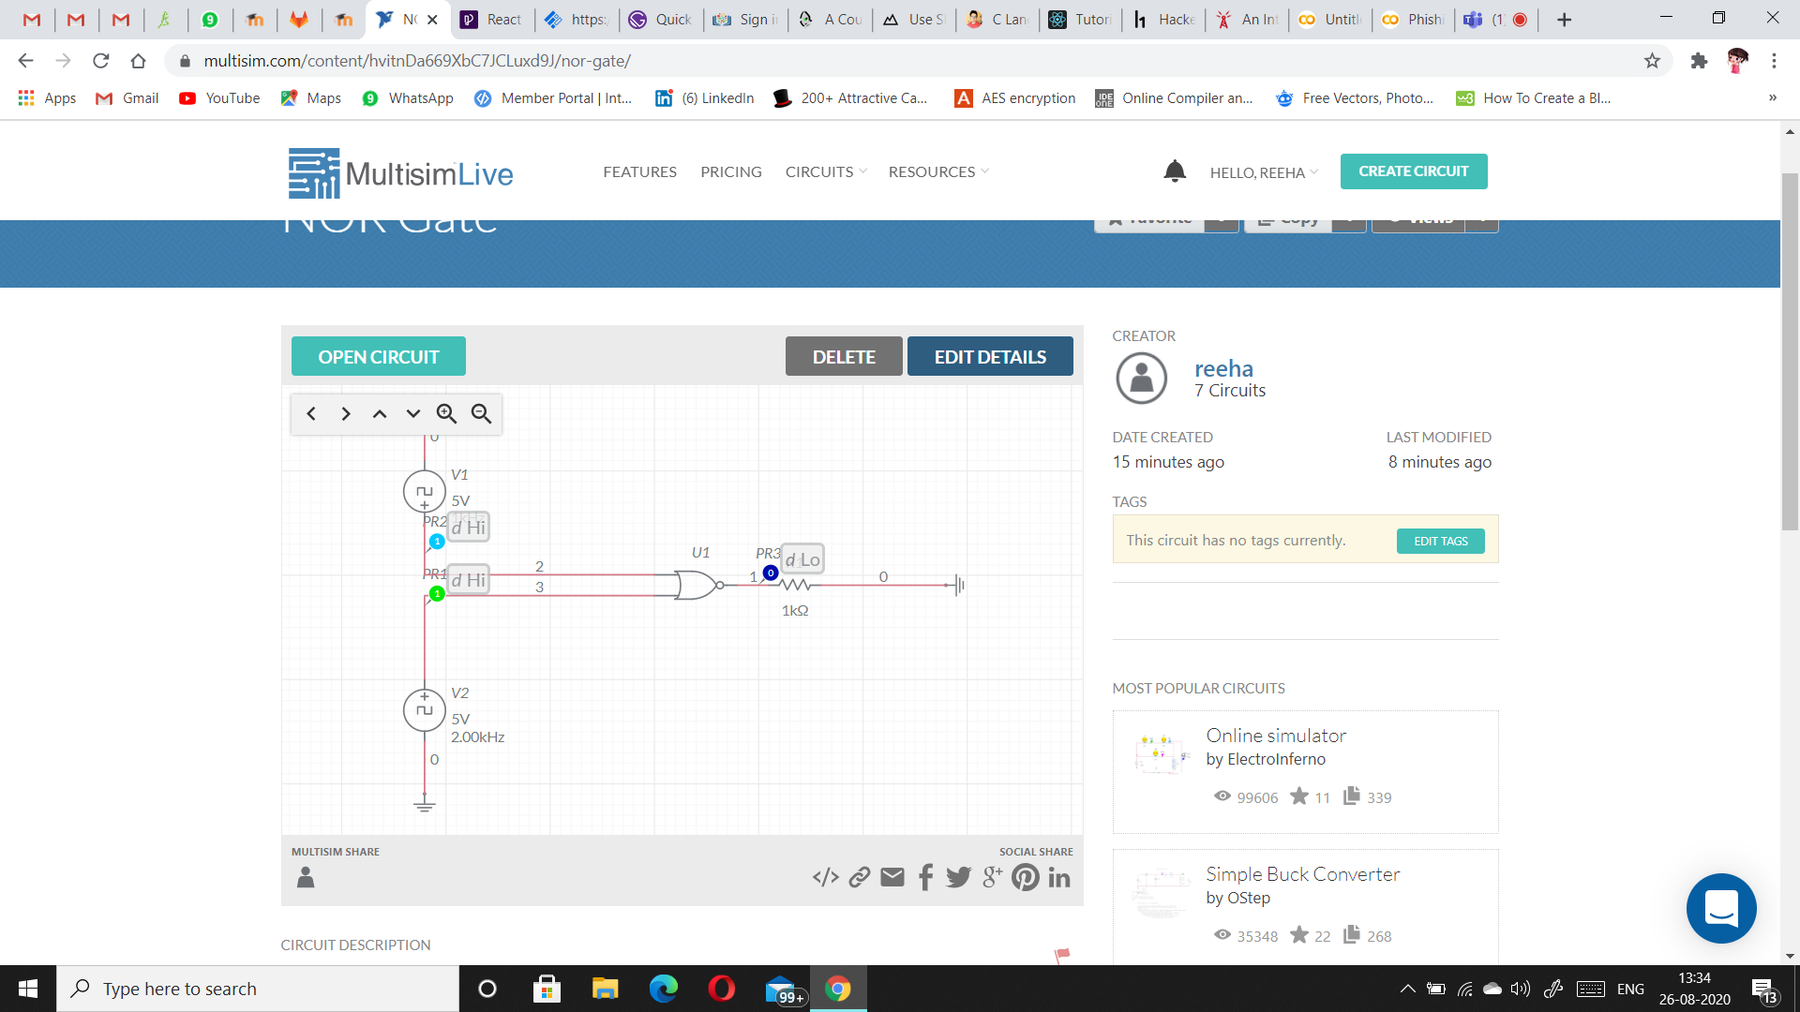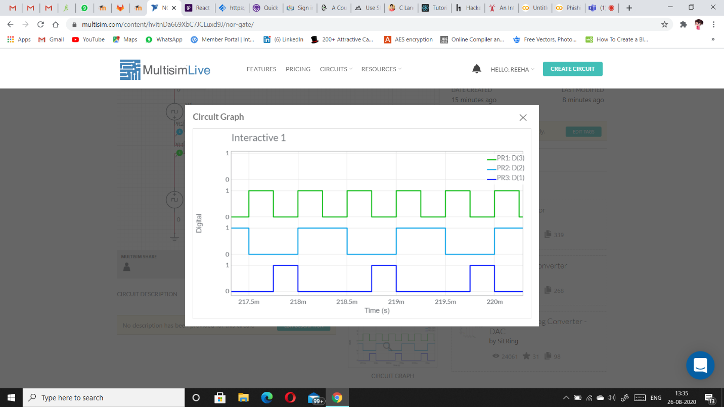

**OR GATE**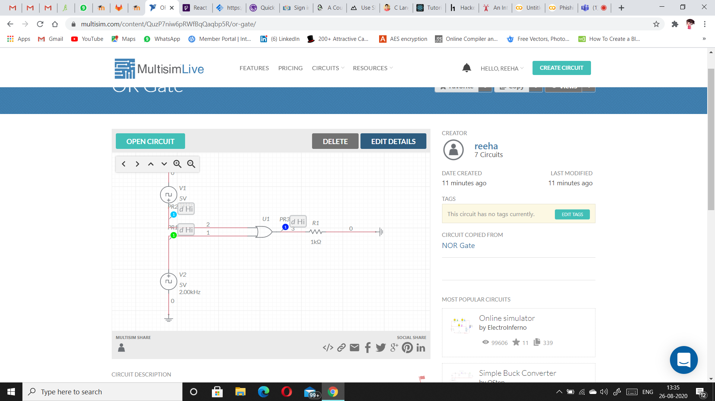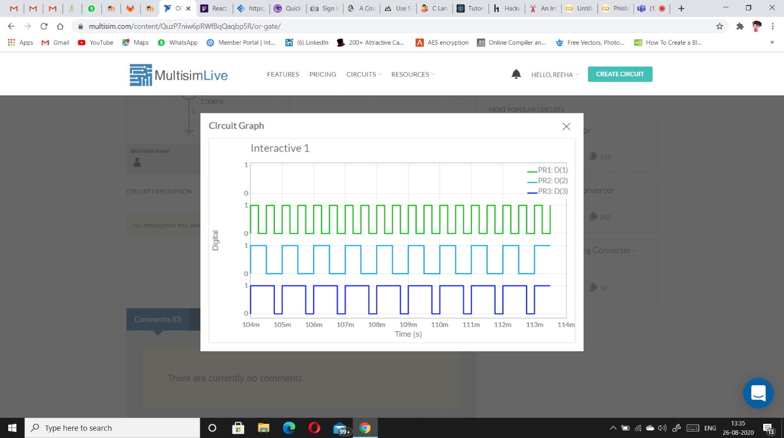

**NAND GATE**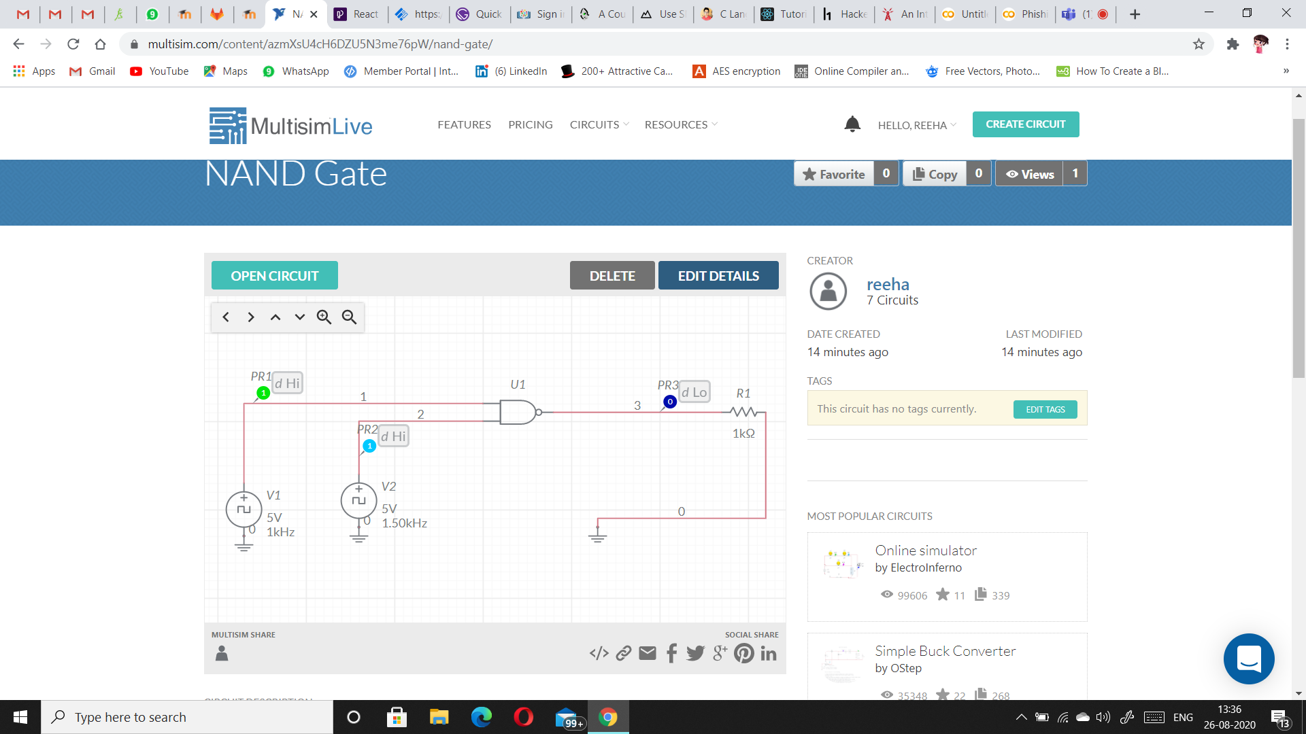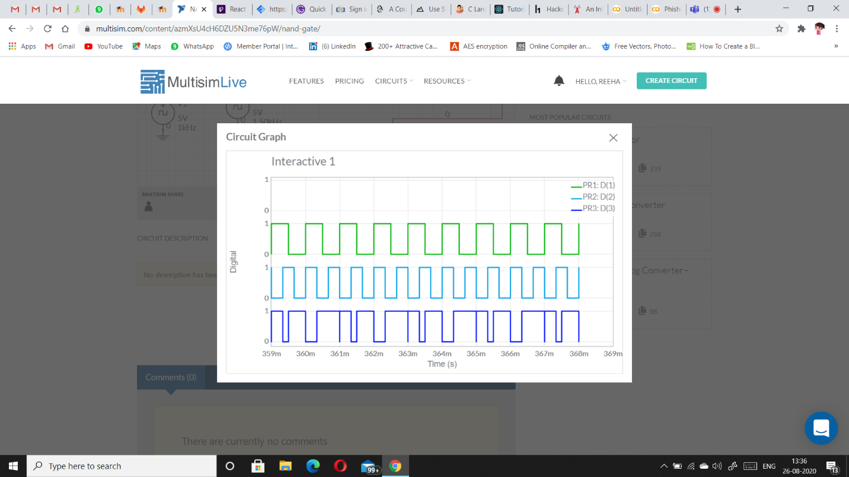

**AND GATE**